CN Simulation

Following is the SS of the GUI

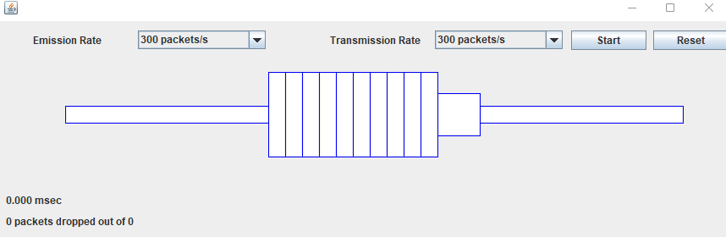

Here thee borders of the network buffer and the links are kept blue. This can perform the simulation for the following 3 scenarios.

1. Emission Rate > Transmission Rate
2. Emission Rate = Transmission Rate
3. Emission Rate < Transmission Rate

This simulation is to demonstrate and to see what would happen if the data is sent is at different than the link capacity.

# Scenario 1

Emission Rate > Transmission Rate

Packets are dropped,

Here as can be seen from the above image, there are packets which are dropping. And it is also animated. Here 4 packets were dropped out of the 35. Because the buffer is full.

Now in following case both are kept same,

# Scenario 2

Both rate are same

Here both are kept same and now it’s working fine without dropping any packets. However it is also not utilizing the available buffer capacity. So transmission could be bit slower or emission could be faster.

# Scenario 3

In this scenario the transmission Rate is much higher than the emission rate, this will further reduce the utilization of the system.

This shows that the simulation is demonstrating the behaviour of the packets in the different conditions.